**Building Our Circle Skills Circle**

**• • • • • •**

(** REMEMBER: Assign students to bring materials for making Talking Pieces – see email)

**PURPOSE**

To build the students’ and teacher’s skills of listening and speaking from the heart.

**MATERIALS** Talking piece, bells.

**PREPARATION** Arrange everyone in a circle of chairs with no other furniture. Welcome to the space of the Circle.

**MINDFULNESS MOMENT** Pause, breathe, and listen to the sound.

**OPENING** Create your own or Play a short version of “The Wave.” Send a move or a sound around the Circle and each person does it in his/her turn.

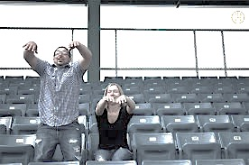

**INTRODUCE “ROUNDS”** A “round” is a pass of the talking piece around the Circle. The keeper poses a question and, as a participant, usually answers first. The keeper then passes the talking piece to the person to his/her left or right. On the first round, participants are invited to say their name as well as respond to the question. Remember, it is always okay for a participant to pass.

MAIN ACTIVITY Reflecting on What It Means to Listen and Speak from the Heart

**EXPLAIN** *In the Circle, we try very hard to listen from the heart and speak from the heart. We are not always able to do that, but we keep trying.*

**ROUND** *What does it mean to listen from the heart?*

**ROUND** *Who do you know who is good at listening from the heart?*

**ROUND** *What does it mean to speak from the heart?*

**ROUND** *Who do you know who is good at speaking from the heart?*

**ROUND** *Who is someone you can talk to from your heart?*

**ROUND** *When is it difficult to listen from the heart and speak from the heart?*

**ROUND** *What helps us listen from the heart and speak from the heart?*

**CHECK-OUT** **ROUND** *How did you like the Circle today?*

**CLOSING** Create your own or play another round of “The Wave.”

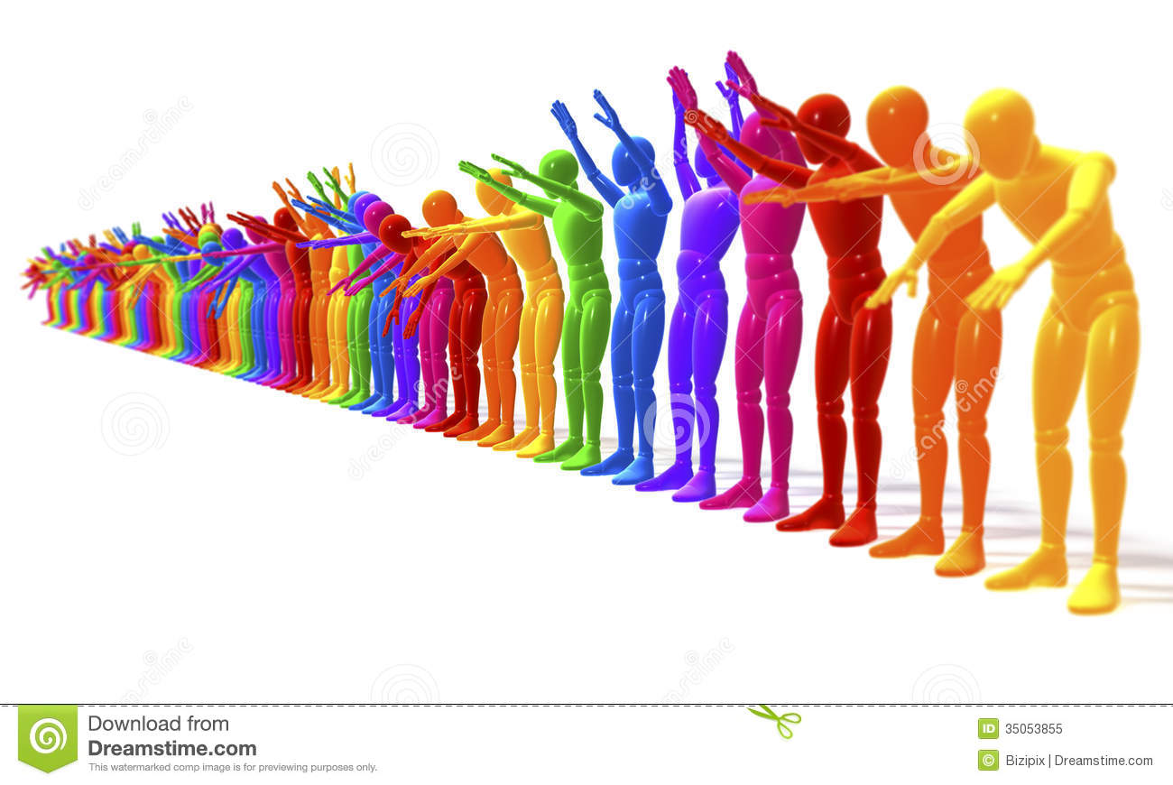

**Thank everyone for participating in the Circle!**